**1.Create an application that takes the name from a text box and shows hello message along with the name entered in text box when the user clicks the okay button**

<RelativeLayout xmlns:android="http://schemas.android.com/apk/res/android"

xmlns:tools="http://schemas.android.com/tools"

android:layout_width="match_parent"

android:layout_height="match_parent"

android:layout_margin="5dp" >

<TextView

android:id="@+id/textView1"

android:layout_width="wrap_content"

android:layout_height="wrap_content"

android:layout_alignParentTop="true"

android:layout_centerHorizontal="true"

android:text="@string/empty"

android:textAppearance="?android:attr/textAppearanceLarge"

android:textColor="#A4C639" />

<TextView

android:id="@+id/textView2"

android:layout_width="wrap_content"

android:layout_height="wrap_content"

android:layout_alignParentLeft="true"

android:layout_below="@+id/textView1"

android:layout_marginTop="23dp"

android:text="@string/input_lable"

android:textAppearance="?android:attr/textAppearanceMedium"

android:textColor="#0099FF" />

<EditText

android:id="@+id/editText1"

android:layout_width="wrap_content"

android:layout_height="wrap_content"

android:layout_alignBottom="@+id/textView2"

android:layout_toRightOf="@+id/textView2"

android:background="#CCCCCC"

android:ems="10"

android:inputType="textPersonName" >

<requestFocus />

</EditText>

<Button

android:id="@+id/button1"

android:layout_width="wrap_content"

android:layout_height="wrap_content"

android:layout_alignParentLeft="true"

android:layout_below="@+id/textView2"

android:layout_marginTop="20dp"

android:background="#0099FF"

android:text="@string/sub"

android:textColor="#FFFFFF" />

</RelativeLayout>

**Activity_main_java**

package com.javapapers.android.form;

import android.os.Bundle;

import android.app.Activity;

import android.view.View;

import android.widget.Button;

import android.widget.EditText;

import android.widget.TextView;

public class FrmActivity extends Activity {

Button mButton;

EditText mEdit;

TextView mText;

@Override

public void onCreate(Bundle savedInstanceState) {

super.onCreate(savedInstanceState);

setContentView(R.layout.activity_frm);

mButton = (Button)findViewById(R.id.button1);

mButton.setOnClickListener(new View.OnClickListener() {

public void onClick(View view) {

mEdit = (EditText)findViewById(R.id.editText1);

mText = (TextView)findViewById(R.id.textView1);

mText.setText("Welcome "+mEdit.getText().toString()+"!");

}

});

}

}

**Output:**

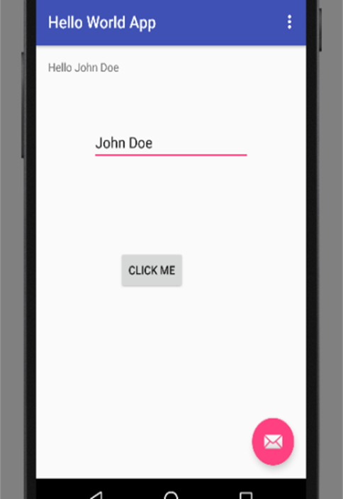

**2.Developer program to implement following UI elements**

**Text view**

**Edit text**

**Toggle button**

**Checkbox**

**Button**

**1 Text view**

**Activity_main_xml**

<?xml version="1.0" encoding="utf-8"?>

<LinearLayout xmlns:android="http://schemas.android.com/apk/res/android"

android:layout_width="match_parent"

android:layout_height="match_parent"

android:layout_marginTop="10dp"

android:orientation="vertical"

android:padding="10dp">

<TextView

android:id="@+id/textView1"

android:layout_width="match_parent"

android:layout_height="wrap_content"

android:layout_marginBottom="10dp"

android:text="Welcome to Tutlane"

android:textColor="#86AD33"

android:textSize="20dp"

android:textStyle="bold" />

<TextView

android:id="@+id/textView2"

android:layout_width="wrap_content"

android:layout_height="wrap_content"

android:layout_marginBottom="15dp"

android:textAllCaps="true" />

<TextView

android:id="@+id/textView3"

android:layout_width="wrap_content"

android:layout_height="wrap_content"

android:text="Welcome to Tutlane"

android:textStyle="bold"

android:textColor="#fff"

android:background="#7F3AB5"

android:layout_marginBottom="15dp"/>

<TextView

android:id="@+id/textView4"

android:layout_width="wrap_content"

a-ndroid:layout_height="wrap_content"

android:autoLink="email|web"

android:text="For more details visit http://tutlane.com and send mail to support@tutlane.com" />

</LinearLayout>

**Activity-main-java**

package com.tutlane.textviewexample;

import android.support.v7.app.AppCompatActivity;

import android.os.Bundle;

import android.widget.TextView;

public class MainActivity extends AppCompatActivity {

@Override

protected void onCreate(Bundle savedInstanceState) {

super.onCreate(savedInstanceState);

setContentView(R.layout.activity_main);

TextView tv = (TextView)findViewById(R.id.textView2);

tv.setText("Welcome to Tutlane");

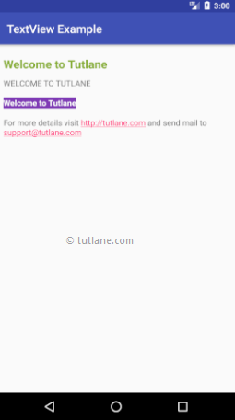

**2.Edit text**

<?xml version="1.0" encoding="utf-8"?>

<LinearLayout xmlns:android="http://schemas.android.com/apk/res/android"

android:layout_width="match_parent"

android:layout_height="match_parent"

android:paddingLeft="40dp"

android:orientation="vertical" android:id="@+id/linearlayout" >

<EditText

android:id="@+id/txtName"

android:layout_width="wrap_content"

android:layout_height="wrap_content"

android:layout_marginTop="25dp"

android:ems="10"

android:hint="Name"

android:inputType="text"

android:selectAllOnFocus="true" />

<EditText

android:id="@+id/txtPwd"

android:layout_width="wrap_content"

android:layout_height="wrap_content"

android:ems="10"

android:hint="Password 0 to 9"

android:inputType="numberPassword" />

<EditText

android:id="@+id/txtEmai"

android:layout_width="wrap_content"

android:layout_height="wrap_content"

android:ems="10"

android:hint="Email"

android:inputType="textEmailAddress" />

<EditText

android:id="@+id/txtDate"

android:layout_width="wrap_content"

android:layout_height="wrap_content"

android:layout_below="@+id/editText3"

android:ems="10"

android:hint="Date"

android:inputType="date" />

<EditText

android:id="@+id/txtPhone"

android:layout_width="wrap_content"

android:layout_height="wrap_content"

android:ems="10"

android:hint="Phone Number"

android:inputType="phone"

android:textColorHint="#FE8DAB"/>

<Button

android:id="@+id/btnSend"

android:layout_width="wrap_content"

android:layout_height="wrap_content"

android:text="submit"

android:textSize="16sp"

android:textStyle="normal|bold" />

<TextView

android:layout_width="wrap_content"

android:layout_height="wrap_content"

android:id="@+id/resultView"

android:layout_marginTop="25dp"

android:textSize="15dp"/>

</LinearLayout>

**MainActivity.java**

package com.tutlane.edittextexample;

import android.support.v7.app.AppCompatActivity;

import android.os.Bundle;

import android.view.View;

import android.widget.Button;

import android.widget.EditText;

import android.widget.TextView;

import org.w3c.dom.Text;

public class MainActivity extends AppCompatActivity {

Button btnSubmit;

EditText name, password, email, dob, phoneno;

TextView result;

@Override

protected void onCreate(Bundle savedInstanceState) {

super.onCreate(savedInstanceState);

setContentView(R.layout.activity_main);

name=(EditText)findViewById(R.id.txtName);

password = (EditText)findViewById(R.id.txtPwd);

email = (EditText)findViewById(R.id.txtEmai);

dob = (EditText)findViewById(R.id.txtDate);

phoneno= (EditText)findViewById(R.id.txtPhone);

btnSubmit = (Button)findViewById(R.id.btnSend);

result = (TextView)findViewById(R.id.resultView);

btnSubmit.setOnClickListener(new View.OnClickListener() {

@Override

public void onClick(View v) {

if (name.getText().toString().isEmpty() || password.getText().toString().isEmpty() || email.getText().toString().isEmpty() || dob.getText().toString().isEmpty()

|| phoneno.getText().toString().isEmpty()) {

result.setText("Please Fill All the Details");

} else {

result.setText("Name - " + name.getText().toString() + " \n" + "Password - " + password.getText().toString()

+ " \n" + "E-Mail - " + email.getText().toString() + " \n" + "DOB - " + dob.getText().toString()

+ " \n" + "Contact - " + phoneno.getText().toString());

}

}

});

}

}

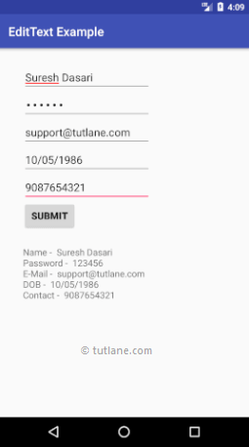

**3.Toggle Button**

activity_main.xml

<?xml version="1.0" encoding="utf-8"?>

<RelativeLayout xmlns:android="http://schemas.android.com/apk/res/android"

android:layout_width="match_parent" android:layout_height="match_parent">

<ToggleButton

android:id="@+id/toggle1"

android:layout_width="wrap_content"

android:layout_height="wrap_content"

android:layout_marginLeft="100dp"

android:layout_marginTop="120dp"

android:checked="true"

android:textOff="OFF"

android:textOn="ON"/>

<ToggleButton

android:id="@+id/toggle2"

android:layout_width="wrap_content"

android:layout_height="wrap_content"

android:layout_alignBottom="@+id/toggle1"

android:layout_toRightOf="@+id/toggle1"

android:textOff="OFF"

android:textOn ="ON"/>

<Button

android:id="@+id/getBtn"

android:layout_width="wrap_content"

android:layout_height="wrap_content"

android:layout_marginLeft="150dp"

android:layout_marginTop="200dp"

android:text="Submit" />

</RelativeLayout>

**MainActivity.java**

package com.tutlane.togglebuttonexample;

import android.support.v7.app.AppCompatActivity;

import android.os.Bundle;

import android.view.View;

import android.widget.Button;

import android.widget.Toast;

import android.widget.ToggleButton;

public class MainActivity extends AppCompatActivity {

@Override

protected void onCreate(Bundle savedInstanceState) {

super.onCreate(savedInstanceState);

setContentView(R.layout.activity_main);

final ToggleButton tb1 = (ToggleButton)findViewById(R.id.toggle1);

final ToggleButton tb2 = (ToggleButton)findViewById(R.id.toggle2);

Button btnGet = (Button)findViewById(R.id.getBtn);

btnGet.setOnClickListener(new View.OnClickListener() {

@Override

public void onClick(View v) {

Toast.makeText(getApplicationContext(), "Toggle Button1 - " + tb1.getText().toString() + " \n" + "Toggle Button2 - " + tb2.getText().toString(),Toast.LENGTH_SHORT).show();

}

});

}

}

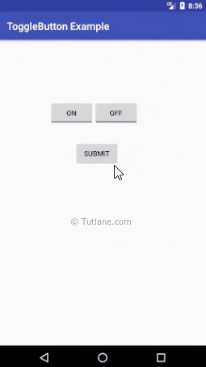

**4.Checkbox**

activity_main.xml

<?xml version="1.0" encoding="utf-8"?>

<LinearLayout xmlns:android="http://schemas.android.com/apk/res/android"

android:orientation="vertical" android:layout_width="match_parent"

android:layout_height="match_parent">

<CheckBox

android:id="@+id/chkJava"

android:layout_width="wrap_content"

android:layout_height="wrap_content"

android:padding="10dp"

android:layout_marginTop="150dp"

android:layout_marginLeft="100dp"

android:text="Java"

android:onClick="onCheckboxClicked"/>

<CheckBox

android:id="@+id/chkPython"

android:layout_width="wrap_content"

android:layout_height="wrap_content"

android:padding="10dp"

android:layout_marginLeft="100dp"

android:text="Python"

android:onClick="onCheckboxClicked"/>

<CheckBox

android:id="@+id/chkAndroid"

android:layout_width="wrap_content"

android:layout_height="wrap_content"

android:padding="10dp"

android:layout_marginLeft="100dp"

android:text="Android"

android:onClick="onCheckboxClicked"/>

<CheckBox

android:id="@+id/chkAngular"

android:layout_width="wrap_content"

android:layout_height="wrap_content"

android:padding="10dp"

android:layout_marginLeft="100dp"

android:text="AngularJS"

android:onClick="onCheckboxClicked"/>

<Button

android:id="@+id/getBtn"

android:layout_width="wrap_content"

android:layout_height="wrap_content"

android:layout_marginLeft="100dp"

android:text="Get Details" />

</LinearLayout>

**MainActivity.java**

package com.tutlane.checkboxexample;

import android.support.v7.app.AppCompatActivity;

import android.os.Bundle;

import android.view.View;

import android.widget.Button;

import android.widget.CheckBox;

import android.widget.Toast;

public class MainActivity extends AppCompatActivity {

CheckBox android, java, angular, python;

@Override

protected void onCreate(Bundle savedInstanceState) {

super.onCreate(savedInstanceState);

setContentView(R.layout.activity_main);

android = (CheckBox)findViewById(R.id.chkAndroid);

angular = (CheckBox)findViewById(R.id.chkAngular);

java = (CheckBox)findViewById(R.id.chkJava);

python = (CheckBox)findViewById(R.id.chkPython);

Button btn = (Button)findViewById(R.id.getBtn);

btn.setOnClickListener(new View.OnClickListener() {

@Override

public void onClick(View v) {

String result = "Selected Courses";

if(android.isChecked()){

result += "\nAndroid";

}

if(angular.isChecked()){

result += "\nAngularJS";

}

if(java.isChecked()){

result += "\nJava";

}

if(python.isChecked()){

result += "\nPython";

}

Toast.makeText(getApplicationContext(), result, Toast.LENGTH_SHORT).show();

}

});

}

public void onCheckboxClicked(View view) {

boolean checked = ((CheckBox) view).isChecked();

String str="";

// Check which checkbox was clicked

switch(view.getId()) {

case R.id.chkAndroid:

str = checked?"Android Selected":"Android Deselected";

break;

case R.id.chkAngular:

str = checked?"AngularJS Selected":"AngularJS Deselected";

break;

case R.id.chkJava:

str = checked?"Java Selected":"Java Deselected";

break;

case R.id.chkPython:

str = checked?"Python Selected":"Python Deselected";

break;

}

Toast.makeText(getApplicationContext(), str, Toast.LENGTH_SHORT).show();

}

}

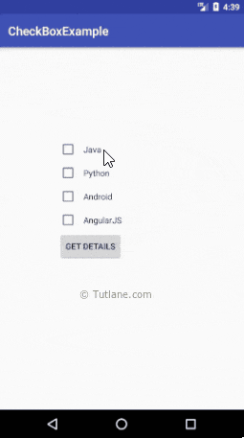

**5.Button**

activity_main.xml

<?xml version="1.0" encoding="utf-8"?>

<LinearLayout xmlns:android="http://schemas.android.com/apk/res/android"

android:orientation="vertical" android:layout_width="match_parent"

android:layout_height="match_parent">

<TextView

android:id="@+id/fstTxt"

android:layout_width="wrap_content"

android:layout_height="wrap_content"

android:layout_marginLeft="100dp"

android:layout_marginTop="150dp"

android:text="First Number" />

<EditText

android:id="@+id/firstNum"

android:layout_width="wrap_content"

android:layout_height="wrap_content"

android:layout_marginLeft="100dp"

android:ems="10" />

<TextView

android:id="@+id/secTxt"

android:layout_width="wrap_content"

android:layout_height="wrap_content"

android:text="Second Number"

android:layout_marginLeft="100dp" />

<EditText

android:id="@+id/secondNum"

android:layout_width="wrap_content"

android:layout_height="wrap_content"

android:layout_marginLeft="100dp"

android:ems="10" />

<Button

android:id="@+id/addBtn"

android:layout_width="wrap_content"

android:layout_height="wrap_content"

android:layout_marginLeft="100dp"

android:text="Add" />

</LinearLayout>

**MainActivity.java**

package com.tutlane.buttonexample;

import android.support.v7.app.AppCompatActivity;

import android.os.Bundle;

import android.view.View;

import android.widget.Button;

import android.widget.EditText;

import android.widget.Toast;

public class MainActivity extends AppCompatActivity {

@Override

protected void onCreate(Bundle savedInstanceState) {

super.onCreate(savedInstanceState);

setContentView(R.layout.activity_main);

final EditText firstNum = (EditText)findViewById(R.id.firstNum);

final EditText secNum = (EditText)findViewById(R.id.secondNum);

Button btnAdd = (Button)findViewById(R.id.addBtn);

btnAdd.setOnClickListener(new View.OnClickListener() {

@Override

public void onClick(View v) {

if(firstNum.getText().toString().isEmpty() || secNum.getText().toString().isEmpty())

{

Toast.makeText(getApplicationContext(), "Please fill all the fields", Toast.LENGTH_SHORT).show();

}

else {

int num1 = Integer.parseInt(firstNum.getText().toString());

int num2 = Integer.parseInt(secNum.getText().toString());

Toast.makeText(getApplicationContext(), "SUM = " + (num1 + num2), Toast.LENGTH_SHORT).show();

}

}

});

}

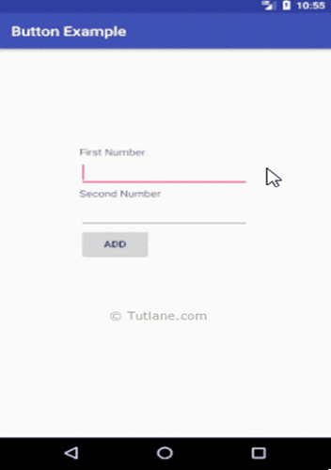

**3) Developer program to implement following UI elements in Frame layout**

**- Auto complete text view**

**- Image button**

**- Radio button and radio group**

**- Date and time picker**

**-Button**

**1.Auto Complete text view**

**File: activity_main.xml**

<?xml version="1.0" encoding="utf-8"?>

< FrameLayout android.support.constraint.ConstraintLayout xmlns:android="http://schemas.android.com/apk/res/android"

xmlns:app="http://schemas.android.com/apk/res-auto"

xmlns:tools="http://schemas.android.com/tools"

android:layout_width="match_parent"

android:layout_height="match_parent"

tools:context="example.javatpoint.com.autocompletetextview.MainActivity">

<TextView

android:layout_width="wrap_content"

android:layout_height="wrap_content"

android:text="What is your favourite programming language?"

app:layout_constraintBottom_toBottomOf="parent"

app:layout_constraintLeft_toLeftOf="parent"

app:layout_constraintRight_toRightOf="parent"

app:layout_constraintTop_toTopOf="parent"

app:layout_constraintVertical_bias="0.032" />

<AutoCompleteTextView

android:id="@+id/autoCompleteTextView"

android:layout_width="200dp"

android:layout_height="wrap_content"

android:layout_marginLeft="92dp"

android:layout_marginTop="144dp"

android:text=""

app:layout_constraintStart_toStartOf="parent"

app:layout_constraintTop_toTopOf="parent" />

</android.support.constraint.ConstraintLayout>

</FrameLayout>

**File: MainActivity.java**

package example.javatpoint.com.autocompletetextview;

import android.graphics.Color;

import android.support.v7.app.AppCompatActivity;

import android.os.Bundle;

import android.widget.ArrayAdapter;

import android.widget.AutoCompleteTextView;

public class MainActivity extends AppCompatActivity {

String[] language ={"C","C++","Java",".NET","iPhone","Android","ASP.NET","PHP"};

@Override

protected void onCreate(Bundle savedInstanceState) {

super.onCreate(savedInstanceState);

setContentView(R.layout.activity_main);

//Creating the instance of ArrayAdapter containing list of language names

ArrayAdapter<String> adapter = new ArrayAdapter<String>

(this,android.R.layout.select_dialog_item,language);

//Getting the instance of AutoCompleteTextView

AutoCompleteTextView actv = (AutoCompleteTextView)findViewById(R.id.autoCompleteTextView);

actv.setThreshold(1);//will start working from first character

actv.setAdapter(adapter);//setting the adapter data into the AutoCompleteTextView

actv.setTextColor(Color.RED);

}

}

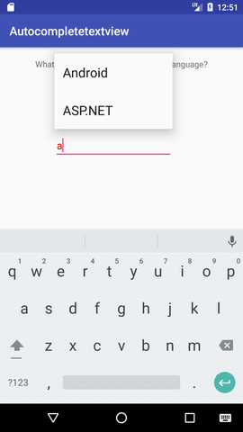

**2.Image Buttuon**

activity_main.xml

<?xml version="1.0" encoding="utf-8"?>

< FrameLayout xmlns:android="http://schemas.android.com/apk/res/android"

android:orientation="vertical" android:layout_width="match_parent"

android:layout_height="match_parent" android:id="@+id/l_layout">

<TextView

android:id="@+id/fstTxt"

android:layout_width="wrap_content"

android:layout_height="wrap_content"

android:layout_marginLeft="100dp"

android:layout_marginTop="150dp"

android:text="First Number"/>

<EditText

android:id="@+id/firstNum"

android:layout_width="wrap_content"

android:layout_height="wrap_content"

android:layout_marginLeft="100dp"

android:ems="10"/>

<TextView

android:id="@+id/secTxt"

android:layout_width="wrap_content"

android:layout_height="wrap_content"

android:text="Second Number"

android:layout_marginLeft="100dp" />

<EditText

android:id="@+id/secondNum"

android:layout_width="wrap_content"

android:layout_height="wrap_content"

android:layout_marginLeft="100dp"

android:ems="10" />

<ImageButton

android:id="@+id/addBtn"

android:layout_width="wrap_content"

android:layout_height="wrap_content"

android:layout_marginLeft="100dp"

android:src="@drawable/add_icon" />

</FrameLayout >

**MainActivity.java**

package com.tutlane.buttonexample;

import android.support.v7.app.AppCompatActivity;

import android.os.Bundle;

import android.view.View;

import android.widget.EditText;

import android.widget.ImageButton;

import android.widget.Toast;

public class MainActivity extends AppCompatActivity {

@Override

protected void onCreate(Bundle savedInstanceState) {

super.onCreate(savedInstanceState);

setContentView(R.layout.activity_main);

final EditText firstNum = (EditText)findViewById(R.id.firstNum);

final EditText secNum = (EditText)findViewById(R.id.secondNum);

ImageButton btnAdd = (ImageButton)findViewById(R.id.addBtn);

btnAdd.setOnClickListener(new View.OnClickListener() {

@Override

public void onClick(View v) {

if(firstNum.getText().toString().isEmpty() || secNum.getText().toString().isEmpty())

{

Toast.makeText(getApplicationContext(), "Please fill all the fields", Toast.LENGTH_SHORT).show();

}

else {

int num1 = Integer.parseInt(firstNum.getText().toString());

int num2 = Integer.parseInt(secNum.getText().toString());

Toast.makeText(getApplicationContext(), "SUM = " + (num1 + num2), Toast.LENGTH_SHORT).show();

}

}

});

}

}

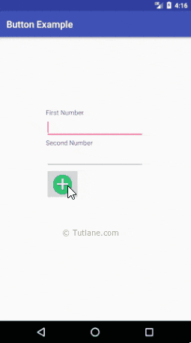

**3a.Radio button**

activity_main.xml

<?xml version="1.0" encoding="utf-8"?>

<FrameLayout xmlns:android="http://schemas.android.com/apk/res/android"

android:layout_width="match_parent" android:layout_height="match_parent">

<TextView

android:layout_width="wrap_content"

android:layout_height="wrap_content"

android:layout_marginTop="150dp"

android:layout_marginLeft="100dp"

android:textSize="18dp"

android:text="Select Your Course"

android:textStyle="bold"

android:id="@+id/txtView"/>

<RadioGroup

android:layout_width="match_parent"

android:layout_height="wrap_content"

android:orientation="vertical"

android:id="@+id/rdGroup"

android:layout_below="@+id/txtView">

<RadioButton

android:id="@+id/rdbJava"

android:layout_width="wrap_content"

android:layout_height="wrap_content"

android:padding="10dp"

android:layout_marginLeft="100dp"

android:text="Java"

android:onClick="onRadioButtonClicked"/>

<RadioButton

android:id="@+id/rdbPython"

android:layout_width="wrap_content"

android:layout_height="wrap_content"

android:padding="10dp"

android:layout_marginLeft="100dp"

android:text="Python"

android:onClick="onRadioButtonClicked"/>

<RadioButton

android:id="@+id/rdbAndroid"

android:layout_width="wrap_content"

android:layout_height="wrap_content"

android:padding="10dp"

android:layout_marginLeft="100dp"

android:text="Android"

android:onClick="onRadioButtonClicked"/>

<RadioButton

android:id="@+id/rdbAngular"

android:layout_width="wrap_content"

android:layout_height="wrap_content"

android:padding="10dp"

android:layout_marginLeft="100dp"

android:text="AngularJS"

android:onClick="onRadioButtonClicked"/>

</RadioGroup>

<Button

android:id="@+id/getBtn"

android:layout_width="wrap_content"

android:layout_height="wrap_content"

android:layout_marginLeft="100dp"

android:layout_below="@+id/rdGroup"

android:text="Get Course" />

</ FrameLayout>

**MainActivity.java**

package com.tutlane.radiobuttonexample;

import android.support.v7.app.AppCompatActivity;

import android.os.Bundle;

import android.view.View;

import android.widget.Button;

import android.widget.RadioButton;

import android.widget.Toast;

public class MainActivity extends AppCompatActivity {

RadioButton android, java, angular, python;

@Override

protected void onCreate(Bundle savedInstanceState) {

super.onCreate(savedInstanceState);

setContentView(R.layout.activity_main);

android = (RadioButton)findViewById(R.id.rdbAndroid);

angular = (RadioButton)findViewById(R.id.rdbAngular);

java = (RadioButton)findViewById(R.id.rdbJava);

python = (RadioButton)findViewById(R.id.rdbPython);

Button btn = (Button)findViewById(R.id.getBtn);

btn.setOnClickListener(new View.OnClickListener() {

@Override

public void onClick(View v) {

String result = "Selected Course: ";

result+= (android.isChecked())?"Android":(angular.isChecked())?"AngularJS":(java.isChecked())?"Java":(python.isChecked())?"Python":"";

Toast.makeText(getApplicationContext(), result, Toast.LENGTH_SHORT).show();

}

});

}

public void onRadioButtonClicked(View view) {

boolean checked = ((RadioButton) view).isChecked();

String str="";

// Check which radio button was clicked

switch(view.getId()) {

case R.id.rdbAndroid:

if(checked)

str = "Android Selected";

break;

case R.id.rdbAngular:

if(checked)

str = "AngularJS Selected";

break;

case R.id.rdbJava:

if(checked)

str = "Java Selected";

break;

case R.id.rdbPython:

if(checked)

str = "Python Selected";

break;

}

Toast.makeText(getApplicationContext(), str, Toast.LENGTH_SHORT).show();

}

}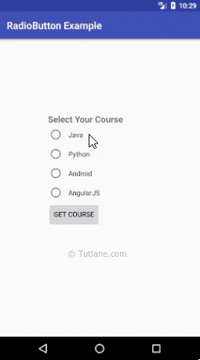

**3b.Radio group button**

activity_main.xml

<?xml version="1.0" encoding="utf-8"?>

<FrameLayout xmlns:android="http://schemas.android.com/apk/res/android"

android:layout_width="match_parent" android:layout_height="match_parent">

<TextView

android:layout_width="wrap_content"

android:layout_height="wrap_content"

android:layout_marginTop="150dp"

android:layout_marginLeft="100dp"

android:textSize="18dp"

android:text="Select Your Course"

android:textStyle="bold"

android:id="@+id/txtView"/>

<RadioGroup

android:layout_width="match_parent"

android:layout_height="wrap_content"

android:orientation="vertical"

android:id="@+id/rdGroup"

android:layout_below="@+id/txtView">

<RadioButton

android:id="@+id/rdbJava"

android:layout_width="wrap_content"

android:layout_height="wrap_content"

android:padding="10dp"

android:layout_marginLeft="100dp"

android:text="Java"

android:onClick="onRadioButtonClicked"/>

<RadioButton

android:id="@+id/rdbPython"

android:layout_width="wrap_content"

android:layout_height="wrap_content"

android:padding="10dp"

android:layout_marginLeft="100dp"

android:text="Python"

android:onClick="onRadioButtonClicked"/>

<RadioButton

android:id="@+id/rdbAndroid"

android:layout_width="wrap_content"

android:layout_height="wrap_content"

android:padding="10dp"

android:layout_marginLeft="100dp"

android:text="Android"

android:onClick="onRadioButtonClicked"/>

<RadioButton

android:id="@+id/rdbAngular"

android:layout_width="wrap_content"

android:layout_height="wrap_content"

android:padding="10dp"

android:layout_marginLeft="100dp"

android:text="AngularJS"

android:onClick="onRadioButtonClicked"/>

</RadioGroup>

<Button

android:id="@+id/getBtn"

android:layout_width="wrap_content"

android:layout_height="wrap_content"

android:layout_marginLeft="100dp"

android:layout_below="@+id/rdGroup"

android:text="Get Course" />

</FrameLayout >

**MainActivity.java**

package com.tutlane.radiobuttonexample;

import android.support.v7.app.AppCompatActivity;

import android.os.Bundle;

import android.view.View;

import android.widget.Button;

import android.widget.RadioButton;

import android.widget.Toast;

public class MainActivity extends AppCompatActivity {

RadioButton android, java, angular, python;

@Override

protected void onCreate(Bundle savedInstanceState) {

super.onCreate(savedInstanceState);

setContentView(R.layout.activity_main);

android = (RadioButton)findViewById(R.id.rdbAndroid);

angular = (RadioButton)findViewById(R.id.rdbAngular);

java = (RadioButton)findViewById(R.id.rdbJava);

python = (RadioButton)findViewById(R.id.rdbPython);

Button btn = (Button)findViewById(R.id.getBtn);

btn.setOnClickListener(new View.OnClickListener() {

@Override

public void onClick(View v) {

String result = "Selected Course: ";

result+= (android.isChecked())?"Android":(angular.isChecked())?"AngularJS":(java.isChecked())?"Java":(python.isChecked())?"Python":"";

Toast.makeText(getApplicationContext(), result, Toast.LENGTH_SHORT).show();

}

});

}

public void onRadioButtonClicked(View view) {

boolean checked = ((RadioButton) view).isChecked();

String str="";

// Check which radio button was clicked

switch(view.getId()) {

case R.id.rdbAndroid:

if(checked)

str = "Android Selected";

break;

case R.id.rdbAngular:

if(checked)

str = "AngularJS Selected";

break;

case R.id.rdbJava:

if(checked)

str = "Java Selected";

break;

case R.id.rdbPython:

if(checked)

str = "Python Selected";

break;

}

Toast.makeText(getApplicationContext(), str, Toast.LENGTH_SHORT).show();

}

}



**4a. Time picker**

activity_main.xml

<?xml version="1.0" encoding="utf-8"?>

<FrameLayout xmlns:android="http://schemas.android.com/apk/res/android"

android:layout_width="match_parent" android:layout_height="match_parent">

<TimePicker

android:id="@+id/timePicker1"

android:layout_width="wrap_content"

android:layout_height="wrap_content"

android:layout_centerHorizontal="true"

android:layout_marginTop="20dp" />

<Button

android:id="@+id/button1"

android:layout_width="wrap_content"

android:layout_height="wrap_content"

android:layout_below="@+id/timePicker1"

android:layout_marginTop="10dp"

android:layout_marginLeft="160dp"

android:text="Get Date" />

<TextView

android:id="@+id/textView1"

android:layout_width="wrap_content"

android:layout_height="wrap_content"

android:layout_below="@+id/button1"

android:layout_marginLeft="120dp"

android:layout_marginTop="10dp"

android:textStyle="bold"

android:textSize="18dp"/>

</FrameLayout >

**MainActivity.java**

package com.tutlane.timepickerexample;

import android.os.Build;

import android.support.v7.app.AppCompatActivity;

import android.os.Bundle;

import android.view.View;

import android.widget.Button;

import android.widget.TextView;

import android.widget.TimePicker;

public class MainActivity extends AppCompatActivity {

TimePicker picker;

Button btnGet;

TextView tvw;

@Override

protected void onCreate(Bundle savedInstanceState) {

super.onCreate(savedInstanceState);

setContentView(R.layout.activity_main);

tvw=(TextView)findViewById(R.id.textView1);

picker=(TimePicker)findViewById(R.id.timePicker1);

picker.setIs24HourView(true);

btnGet=(Button)findViewById(R.id.button1);

btnGet.setOnClickListener(new View.OnClickListener() {

@Override

public void onClick(View v) {

int hour, minute;

String am_pm;

if (Build.VERSION.SDK_INT >= 23 ){

hour = picker.getHour();

minute = picker.getMinute();

}

else{

hour = picker.getCurrentHour();

minute = picker.getCurrentMinute();

}

if(hour > 12) {

am_pm = "PM";

hour = hour - 12;

}

else

{

am_pm="AM";

}

tvw.setText("Selected Date: "+ hour +":"+ minute+" "+am_pm);

}

});

}

}

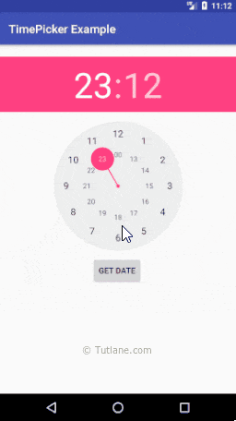

**4b**.**Date picker**

**activity_main.xml**

<?xml version="1.0" encoding="utf-8"?>

<FrameLayout xmlns:android="http://schemas.android.com/apk/res/android"

android:layout_width="match_parent" android:layout_height="match_parent">

<DatePicker

android:id="@+id/datePicker1"

android:layout_width="wrap_content"

android:layout_height="wrap_content"

android:layout_centerHorizontal="true"

android:layout_marginTop="20dp" />

<Button

android:id="@+id/button1"

android:layout_width="wrap_content"

android:layout_height="wrap_content"

android:layout_below="@+id/datePicker1"

android:layout_marginLeft="100dp"

android:text="Get Date" />

<TextView

android:id="@+id/textView1"

android:layout_width="wrap_content"

android:layout_height="wrap_content"

android:layout_below="@+id/button1"

android:layout_marginLeft="100dp"

android:layout_marginTop="10dp"

android:textStyle="bold"

android:textSize="18dp"/>

</FrameLayout >

**MainActivity.java**

package com.tutlane.datepickerexample;  
import android.support.v7.app.AppCompatActivity;  
import android.os.Bundle;  
import android.view.View;  
import android.widget.Button;  
import android.widget.DatePicker;  
import android.widget.TextView;  
  
public class MainActivity extends AppCompatActivity {  
    DatePicker picker;  
    Button btnGet;  
    TextView tvw;  
    @Override  
    protected void onCreate(Bundle savedInstanceState) {  
        super.onCreate(savedInstanceState);  
        setContentView(R.layout.activity_main);  
        tvw=(TextView)findViewById(R.id.textView1);  
        picker=(DatePicker)findViewById(R.id.datePicker1);  
        btnGet=(Button)findViewById(R.id.button1);  
        btnGet.setOnClickListener(new View.OnClickListener() {  
            @Override  
            public void onClick(View v) {  
                tvw.setText("Selected Date: "+ picker.getDayOfMonth()+"/"+ (picker.getMonth() + 1)+"/"+picker.getYear());  
            }  
        });  
    }  
}

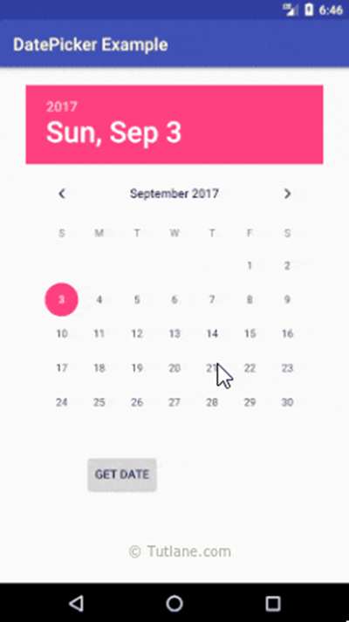

**5.Button**

activity_main.xml

<?xml version="1.0" encoding="utf-8"?>

<FrameLayout xmlns:android="http://schemas.android.com/apk/res/android"

android:orientation="vertical" android:layout_width="match_parent"

android:layout_height="match_parent">

<TextView

android:id="@+id/fstTxt"

android:layout_width="wrap_content"

android:layout_height="wrap_content"

android:layout_marginLeft="100dp"

android:layout_marginTop="150dp"

android:text="First Number" />

<EditText

android:id="@+id/firstNum"

android:layout_width="wrap_content"

android:layout_height="wrap_content"

android:layout_marginLeft="100dp"

android:ems="10" />

<TextView

android:id="@+id/secTxt"

android:layout_width="wrap_content"

android:layout_height="wrap_content"

android:text="Second Number"

android:layout_marginLeft="100dp" />

<EditText

android:id="@+id/secondNum"

android:layout_width="wrap_content"

android:layout_height="wrap_content"

android:layout_marginLeft="100dp"

android:ems="10" />

<Button

android:id="@+id/addBtn"

android:layout_width="wrap_content"

android:layout_height="wrap_content"

android:layout_marginLeft="100dp"

android:text="Add" />

</FrameLayout >

**MainActivity.java**

package com.tutlane.buttonexample;

import android.support.v7.app.AppCompatActivity;

import android.os.Bundle;

import android.view.View;

import android.widget.Button;

import android.widget.EditText;

import android.widget.Toast;

public class MainActivity extends AppCompatActivity {

@Override

protected void onCreate(Bundle savedInstanceState) {

super.onCreate(savedInstanceState);

setContentView(R.layout.activity_main);

final EditText firstNum = (EditText)findViewById(R.id.firstNum);

final EditText secNum = (EditText)findViewById(R.id.secondNum);

Button btnAdd = (Button)findViewById(R.id.addBtn);

btnAdd.setOnClickListener(new View.OnClickListener() {

@Override

public void onClick(View v) {

if(firstNum.getText().toString().isEmpty() || secNum.getText().toString().isEmpty())

{

Toast.makeText(getApplicationContext(), "Please fill all the fields", Toast.LENGTH_SHORT).show();

}

else {

int num1 = Integer.parseInt(firstNum.getText().toString());

int num2 = Integer.parseInt(secNum.getText().toString());

Toast.makeText(getApplicationContext(), "SUM = " + (num1 + num2), Toast.LENGTH_SHORT).show();

}

}

});

}

**4) Developer program to implement following UI elements in Table layout**

**- Scroll view**

**- Radio button and radio group**

**- Edit text**

**-Button**

**1.Scroll view**

**File: activity_main.xml**

<?xml version="1.0" encoding="utf-8"?>

<TableLayout xmlns:android="http://schemas.android.com/apk/res/android"

xmlns:tools="http://schemas.android.com/tools"

android:layout_width="match_parent"

android:layout_height="match_parent"

android:paddingBottom="@dimen/activity_vertical_margin"

android:paddingLeft="@dimen/activity_horizontal_margin"

android:paddingRight="@dimen/activity_horizontal_margin"

android:paddingTop="@dimen/activity_vertical_margin"

tools:context="com.example.test.scrollviews.MainActivity">

<TextView

android:layout_width="wrap_content"

android:layout_height="wrap_content"

android:textAppearance="?android:attr/textAppearanceMedium"

android:text="Vertical ScrollView example"

android:id="@+id/textView"

android:layout_gravity="center_horizontal"

android:layout_centerHorizontal="true"

android:layout_alignParentTop="true" />

<ScrollView android:layout_marginTop="30dp"

android:layout_width="fill_parent"

android:layout_height="wrap_content"

android:id="@+id/scrollView">

<LinearLayout

android:layout_width="fill_parent"

android:layout_height="fill_parent"

android:orientation="vertical" >

<Button

android:layout_width="fill_parent"

android:layout_height="wrap_content"

android:text="Button 1" />

<Button

android:layout_width="fill_parent"

android:layout_height="wrap_content"

android:text="Button 2" />

<Button

android:layout_width="fill_parent"

android:layout_height="wrap_content"

android:text="Button 3" />

<Button

android:layout_width="fill_parent"

android:layout_height="wrap_content"

android:text="Button 4" />

<Button

android:layout_width="fill_parent"

android:layout_height="wrap_content"

android:text="Button 5" />

<Button

android:layout_width="fill_parent"

android:layout_height="wrap_content"

android:text="Button 6" />

<Button

android:layout_width="fill_parent"

android:layout_height="wrap_content"

android:text="Button 7" />

<Button

android:layout_width="fill_parent"

android:layout_height="wrap_content"

android:text="Button 8" />

<Button

android:layout_width="fill_parent"

android:layout_height="wrap_content"

android:text="Button 9" />

<Button

android:layout_width="fill_parent"

android:layout_height="wrap_content"

android:text="Button 10" />

<Button

android:layout_width="fill_parent"

android:layout_height="wrap_content"

android:text="Button 11" />

<Button

android:layout_width="fill_parent"

android:layout_height="wrap_content"

android:text="Button 12" />

<Button

android:layout_width="fill_parent"

android:layout_height="wrap_content"

android:text="Button 13" />

<Button

android:layout_width="fill_parent"

android:layout_height="wrap_content"

android:text="Button 14" />

<Button

android:layout_width="fill_parent"

android:layout_height="wrap_content"

android:text="Button 15" />

<Button

android:layout_width="fill_parent"

android:layout_height="wrap_content"

android:text="Button 16" />

<Button

android:layout_width="fill_parent"

android:layout_height="wrap_content"

android:text="Button 17" />

<Button

android:layout_width="fill_parent"

android:layout_height="wrap_content"

android:text="Button 18" />

<Button

android:layout_width="fill_parent"

android:layout_height="wrap_content"

android:text="Button 19" />

<Button

android:layout_width="fill_parent"

android:layout_height="wrap_content"

android:text="Button 20" />

</LinearLayout>

</ScrollView>

</TableLayout>

**File: MainActivity.java**

package com.example.test.scrollviews;

import android.support.v7.app.AppCompatActivity;

import android.os.Bundle;

public class MainActivity extends AppCompatActivity {

@Override

protected void onCreate(Bundle savedInstanceState) {

super.onCreate(savedInstanceState);

setContentView(R.layout.activity_main);

}

}

**Output:**

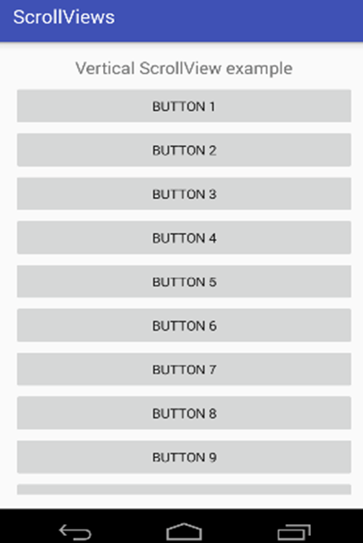

**2a.Radio button**

activity_main.xml

<?xml version="1.0" encoding="utf-8"?>

<TableLayout xmlns:android="http://schemas.android.com/apk/res/android"

android:layout_width="match_parent" android:layout_height="match_parent">

<TextView

android:layout_width="wrap_content"

android:layout_height="wrap_content"

android:layout_marginTop="150dp"

android:layout_marginLeft="100dp"

android:textSize="18dp"

android:text="Select Your Course"

android:textStyle="bold"

android:id="@+id/txtView"/>

<RadioGroup

android:layout_width="match_parent"

android:layout_height="wrap_content"

android:orientation="vertical"

android:id="@+id/rdGroup"

android:layout_below="@+id/txtView">

<RadioButton

android:id="@+id/rdbJava"

android:layout_width="wrap_content"

android:layout_height="wrap_content"

android:padding="10dp"

android:layout_marginLeft="100dp"

android:text="Java"

android:onClick="onRadioButtonClicked"/>

<RadioButton

android:id="@+id/rdbPython"

android:layout_width="wrap_content"

android:layout_height="wrap_content"

android:padding="10dp"

android:layout_marginLeft="100dp"

android:text="Python"

android:onClick="onRadioButtonClicked"/>

<RadioButton

android:id="@+id/rdbAndroid"

android:layout_width="wrap_content"

android:layout_height="wrap_content"

android:padding="10dp"

android:layout_marginLeft="100dp"

android:text="Android"

android:onClick="onRadioButtonClicked"/>

<RadioButton

android:id="@+id/rdbAngular"

android:layout_width="wrap_content"

android:layout_height="wrap_content"

android:padding="10dp"

android:layout_marginLeft="100dp"

android:text="AngularJS"

android:onClick="onRadioButtonClicked"/>

</RadioGroup>

<Button

android:id="@+id/getBtn"

android:layout_width="wrap_content"

android:layout_height="wrap_content"

android:layout_marginLeft="100dp"

android:layout_below="@+id/rdGroup"

android:text="Get Course" />

</TableLayout>

**MainActivity.java**

package com.tutlane.radiobuttonexample;

import android.support.v7.app.AppCompatActivity;

import android.os.Bundle;

import android.view.View;

import android.widget.Button;

import android.widget.RadioButton;

import android.widget.Toast;

public class MainActivity extends AppCompatActivity {

RadioButton android, java, angular, python;

@Override

protected void onCreate(Bundle savedInstanceState) {

super.onCreate(savedInstanceState);

setContentView(R.layout.activity_main);

android = (RadioButton)findViewById(R.id.rdbAndroid);

angular = (RadioButton)findViewById(R.id.rdbAngular);

java = (RadioButton)findViewById(R.id.rdbJava);

python = (RadioButton)findViewById(R.id.rdbPython);

Button btn = (Button)findViewById(R.id.getBtn);

btn.setOnClickListener(new View.OnClickListener() {

@Override

public void onClick(View v) {

String result = "Selected Course: ";

result+= (android.isChecked())?"Android":(angular.isChecked())?"AngularJS":(java.isChecked())?"Java":(python.isChecked())?"Python":"";

Toast.makeText(getApplicationContext(), result, Toast.LENGTH_SHORT).show();

}

});

}

public void onRadioButtonClicked(View view) {

boolean checked = ((RadioButton) view).isChecked();

String str="";

// Check which radio button was clicked

switch(view.getId()) {

case R.id.rdbAndroid:

if(checked)

str = "Android Selected";

break;

case R.id.rdbAngular:

if(checked)

str = "AngularJS Selected";

break;

case R.id.rdbJava:

if(checked)

str = "Java Selected";

break;

case R.id.rdbPython:

if(checked)

str = "Python Selected";

break;

}

Toast.makeText(getApplicationContext(), str, Toast.LENGTH_SHORT).show();

}

}



**2b.Radio group button**

activity_main.xml

<?xml version="1.0" encoding="utf-8"?>

<TableLayout xmlns:android="http://schemas.android.com/apk/res/android"

android:layout_width="match_parent" android:layout_height="match_parent">

<TextView

android:layout_width="wrap_content"

android:layout_height="wrap_content"

android:layout_marginTop="150dp"

android:layout_marginLeft="100dp"

android:textSize="18dp"

android:text="Select Your Course"

android:textStyle="bold"

android:id="@+id/txtView"/>

<RadioGroup

android:layout_width="match_parent"

android:layout_height="wrap_content"

android:orientation="vertical"

android:id="@+id/rdGroup"

android:layout_below="@+id/txtView">

<RadioButton

android:id="@+id/rdbJava"

android:layout_width="wrap_content"

android:layout_height="wrap_content"

android:padding="10dp"

android:layout_marginLeft="100dp"

android:text="Java"

android:onClick="onRadioButtonClicked"/>

<RadioButton

android:id="@+id/rdbPython"

android:layout_width="wrap_content"

android:layout_height="wrap_content"

android:padding="10dp"

android:layout_marginLeft="100dp"

android:text="Python"

android:onClick="onRadioButtonClicked"/>

<RadioButton

android:id="@+id/rdbAndroid"

android:layout_width="wrap_content"

android:layout_height="wrap_content"

android:padding="10dp"

android:layout_marginLeft="100dp"

android:text="Android"

android:onClick="onRadioButtonClicked"/>

<RadioButton

android:id="@+id/rdbAngular"

android:layout_width="wrap_content"

android:layout_height="wrap_content"

android:padding="10dp"

android:layout_marginLeft="100dp"

android:text="AngularJS"

android:onClick="onRadioButtonClicked"/>

</RadioGroup>

<Button

android:id="@+id/getBtn"

android:layout_width="wrap_content"

android:layout_height="wrap_content"

android:layout_marginLeft="100dp"

android:layout_below="@+id/rdGroup"

android:text="Get Course" />

</TableLayout>

**MainActivity.java**

package com.tutlane.radiobuttonexample;

import android.support.v7.app.AppCompatActivity;

import android.os.Bundle;

import android.view.View;

import android.widget.Button;

import android.widget.RadioButton;

import android.widget.Toast;

public class MainActivity extends AppCompatActivity {

RadioButton android, java, angular, python;

@Override

protected void onCreate(Bundle savedInstanceState) {

super.onCreate(savedInstanceState);

setContentView(R.layout.activity_main);

android = (RadioButton)findViewById(R.id.rdbAndroid);

angular = (RadioButton)findViewById(R.id.rdbAngular);

java = (RadioButton)findViewById(R.id.rdbJava);

python = (RadioButton)findViewById(R.id.rdbPython);

Button btn = (Button)findViewById(R.id.getBtn);

btn.setOnClickListener(new View.OnClickListener() {

@Override

public void onClick(View v) {

String result = "Selected Course: ";

result+= (android.isChecked())?"Android":(angular.isChecked())?"AngularJS":(java.isChecked())?"Java":(python.isChecked())?"Python":"";

Toast.makeText(getApplicationContext(), result, Toast.LENGTH_SHORT).show();

}

});

}

public void onRadioButtonClicked(View view) {

boolean checked = ((RadioButton) view).isChecked();

String str="";

// Check which radio button was clicked

switch(view.getId()) {

case R.id.rdbAndroid:

if(checked)

str = "Android Selected";

break;

case R.id.rdbAngular:

if(checked)

str = "AngularJS Selected";

break;

case R.id.rdbJava:

if(checked)

str = "Java Selected";

break;

case R.id.rdbPython:

if(checked)

str = "Python Selected";

break;

}

Toast.makeText(getApplicationContext(), str, Toast.LENGTH_SHORT).show();

}

}



**3.Edit text**

<?xml version="1.0" encoding="utf-8"?>

<TableLayout xmlns:android="http://schemas.android.com/apk/res/android"

android:layout_width="match_parent"

android:layout_height="match_parent"

android:paddingLeft="40dp"

android:orientation="vertical" android:id="@+id/linearlayout" >

<EditText

android:id="@+id/txtName"

android:layout_width="wrap_content"

android:layout_height="wrap_content"

android:layout_marginTop="25dp"

android:ems="10"

android:hint="Name"

android:inputType="text"

android:selectAllOnFocus="true" />

<EditText

android:id="@+id/txtPwd"

android:layout_width="wrap_content"

android:layout_height="wrap_content"

android:ems="10"

android:hint="Password 0 to 9"

android:inputType="numberPassword" />

<EditText

android:id="@+id/txtEmai"

android:layout_width="wrap_content"

android:layout_height="wrap_content"

android:ems="10"

android:hint="Email"

android:inputType="textEmailAddress" />

<EditText

android:id="@+id/txtDate"

android:layout_width="wrap_content"

android:layout_height="wrap_content"

android:layout_below="@+id/editText3"

android:ems="10"

android:hint="Date"

android:inputType="date" />

<EditText

android:id="@+id/txtPhone"

android:layout_width="wrap_content"

android:layout_height="wrap_content"

android:ems="10"

android:hint="Phone Number"

android:inputType="phone"

android:textColorHint="#FE8DAB"/>

<Button

android:id="@+id/btnSend"

android:layout_width="wrap_content"

android:layout_height="wrap_content"

android:text="submit"

android:textSize="16sp"

android:textStyle="normal|bold" />

<TextView

android:layout_width="wrap_content"

android:layout_height="wrap_content"

android:id="@+id/resultView"

android:layout_marginTop="25dp"

android:textSize="15dp"/>

</TableLayout>

**MainActivity.java**

package com.tutlane.edittextexample;

import android.support.v7.app.AppCompatActivity;

import android.os.Bundle;

import android.view.View;

import android.widget.Button;

import android.widget.EditText;

import android.widget.TextView;

import org.w3c.dom.Text;

public class MainActivity extends AppCompatActivity {

Button btnSubmit;

EditText name, password, email, dob, phoneno;

TextView result;

@Override

protected void onCreate(Bundle savedInstanceState) {

super.onCreate(savedInstanceState);

setContentView(R.layout.activity_main);

name=(EditText)findViewById(R.id.txtName);

password = (EditText)findViewById(R.id.txtPwd);

email = (EditText)findViewById(R.id.txtEmai);

dob = (EditText)findViewById(R.id.txtDate);

phoneno= (EditText)findViewById(R.id.txtPhone);

btnSubmit = (Button)findViewById(R.id.btnSend);

result = (TextView)findViewById(R.id.resultView);

btnSubmit.setOnClickListener(new View.OnClickListener() {

@Override

public void onClick(View v) {

if (name.getText().toString().isEmpty() || password.getText().toString().isEmpty() || email.getText().toString().isEmpty() || dob.getText().toString().isEmpty()

|| phoneno.getText().toString().isEmpty()) {

result.setText("Please Fill All the Details");

} else {

result.setText("Name - " + name.getText().toString() + " \n" + "Password - " + password.getText().toString()

+ " \n" + "E-Mail - " + email.getText().toString() + " \n" + "DOB - " + dob.getText().toString()

+ " \n" + "Contact - " + phoneno.getText().toString());

}

}

});

}

}



**4.Button**

activity_main.xml

<?xml version="1.0" encoding="utf-8"?>

<TableLayout xmlns:android="http://schemas.android.com/apk/res/android"

android:orientation="vertical" android:layout_width="match_parent"

android:layout_height="match_parent">

<TextView

android:id="@+id/fstTxt"

android:layout_width="wrap_content"

android:layout_height="wrap_content"

android:layout_marginLeft="100dp"

android:layout_marginTop="150dp"

android:text="First Number" />

<EditText

android:id="@+id/firstNum"

android:layout_width="wrap_content"

android:layout_height="wrap_content"

android:layout_marginLeft="100dp"

android:ems="10" />

<TextView

android:id="@+id/secTxt"

android:layout_width="wrap_content"

android:layout_height="wrap_content"

android:text="Second Number"

android:layout_marginLeft="100dp" />

<EditText

android:id="@+id/secondNum"

android:layout_width="wrap_content"

android:layout_height="wrap_content"

android:layout_marginLeft="100dp"

android:ems="10" />

<Button

android:id="@+id/addBtn"

android:layout_width="wrap_content"

android:layout_height="wrap_content"

android:layout_marginLeft="100dp"

android:text="Add" />

</TableLayout>

**MainActivity.java**

package com.tutlane.buttonexample;

import android.support.v7.app.AppCompatActivity;

import android.os.Bundle;

import android.view.View;

import android.widget.Button;

import android.widget.EditText;

import android.widget.Toast;

public class MainActivity extends AppCompatActivity {

@Override

protected void onCreate(Bundle savedInstanceState) {

super.onCreate(savedInstanceState);

setContentView(R.layout.activity_main);

final EditText firstNum = (EditText)findViewById(R.id.firstNum);

final EditText secNum = (EditText)findViewById(R.id.secondNum);

Button btnAdd = (Button)findViewById(R.id.addBtn);

btnAdd.setOnClickListener(new View.OnClickListener() {

@Override

public void onClick(View v) {

if(firstNum.getText().toString().isEmpty() || secNum.getText().toString().isEmpty())

{

Toast.makeText(getApplicationContext(), "Please fill all the fields", Toast.LENGTH_SHORT).show();

}

else {

int num1 = Integer.parseInt(firstNum.getText().toString());

int num2 = Integer.parseInt(secNum.getText().toString());

Toast.makeText(getApplicationContext(), "SUM = " + (num1 + num2), Toast.LENGTH_SHORT).show();

}

}

});

}



**5) Developer program to implement following UI elements in Relative layout**

**- Toggle button**

**- Image button**

**- Date and time picker**

**- Button**

**1.Toggle Button**

activity_main.xml

<?xml version="1.0" encoding="utf-8"?>

<RelativeLayout xmlns:android="http://schemas.android.com/apk/res/android"

android:layout_width="match_parent" android:layout_height="match_parent">

<ToggleButton

android:id="@+id/toggle1"

android:layout_width="wrap_content"

android:layout_height="wrap_content"

android:layout_marginLeft="100dp"

android:layout_marginTop="120dp"

android:checked="true"

android:textOff="OFF"

android:textOn="ON"/>

<ToggleButton

android:id="@+id/toggle2"

android:layout_width="wrap_content"

android:layout_height="wrap_content"

android:layout_alignBottom="@+id/toggle1"

android:layout_toRightOf="@+id/toggle1"

android:textOff="OFF"

android:textOn ="ON"/>

<Button

android:id="@+id/getBtn"

android:layout_width="wrap_content"

android:layout_height="wrap_content"

android:layout_marginLeft="150dp"

android:layout_marginTop="200dp"

android:text="Submit" />

</RelativeLayout>

**MainActivity.java**

package com.tutlane.togglebuttonexample;

import android.support.v7.app.AppCompatActivity;

import android.os.Bundle;

import android.view.View;

import android.widget.Button;

import android.widget.Toast;

import android.widget.ToggleButton;

public class MainActivity extends AppCompatActivity {

@Override

protected void onCreate(Bundle savedInstanceState) {

super.onCreate(savedInstanceState);

setContentView(R.layout.activity_main);

final ToggleButton tb1 = (ToggleButton)findViewById(R.id.toggle1);

final ToggleButton tb2 = (ToggleButton)findViewById(R.id.toggle2);

Button btnGet = (Button)findViewById(R.id.getBtn);

btnGet.setOnClickListener(new View.OnClickListener() {

@Override

public void onClick(View v) {

Toast.makeText(getApplicationContext(), "Toggle Button1 - " + tb1.getText().toString() + " \n" + "Toggle Button2 - " + tb2.getText().toString(),Toast.LENGTH_SHORT).show();

}

});

}

}



**2.Image Buttuon**

activity_main.xml

<?xml version="1.0" encoding="utf-8"?>

<RelativeLayout xmlns:android="http://schemas.android.com/apk/res/android"

android:orientation="vertical" android:layout_width="match_parent"

android:layout_height="match_parent" android:id="@+id/l_layout">

<TextView

android:id="@+id/fstTxt"

android:layout_width="wrap_content"

android:layout_height="wrap_content"

android:layout_marginLeft="100dp"

android:layout_marginTop="150dp"

android:text="First Number"/>

<EditText

android:id="@+id/firstNum"

android:layout_width="wrap_content"

android:layout_height="wrap_content"

android:layout_marginLeft="100dp"

android:ems="10"/>

<TextView

android:id="@+id/secTxt"

android:layout_width="wrap_content"

android:layout_height="wrap_content"

android:text="Second Number"

android:layout_marginLeft="100dp" />

<EditText

android:id="@+id/secondNum"

android:layout_width="wrap_content"

android:layout_height="wrap_content"

android:layout_marginLeft="100dp"

android:ems="10" />

<ImageButton

android:id="@+id/addBtn"

android:layout_width="wrap_content"

android:layout_height="wrap_content"

android:layout_marginLeft="100dp"

android:src="@drawable/add_icon" />

</RelativeLayout>

**MainActivity.java**

package com.tutlane.buttonexample;

import android.support.v7.app.AppCompatActivity;

import android.os.Bundle;

import android.view.View;

import android.widget.EditText;

import android.widget.ImageButton;

import android.widget.Toast;

public class MainActivity extends AppCompatActivity {

@Override

protected void onCreate(Bundle savedInstanceState) {

super.onCreate(savedInstanceState);

setContentView(R.layout.activity_main);

final EditText firstNum = (EditText)findViewById(R.id.firstNum);

final EditText secNum = (EditText)findViewById(R.id.secondNum);

ImageButton btnAdd = (ImageButton)findViewById(R.id.addBtn);

btnAdd.setOnClickListener(new View.OnClickListener() {

@Override

public void onClick(View v) {

if(firstNum.getText().toString().isEmpty() || secNum.getText().toString().isEmpty())

{

Toast.makeText(getApplicationContext(), "Please fill all the fields", Toast.LENGTH_SHORT).show();

}

else {

int num1 = Integer.parseInt(firstNum.getText().toString());

int num2 = Integer.parseInt(secNum.getText().toString());

Toast.makeText(getApplicationContext(), "SUM = " + (num1 + num2), Toast.LENGTH_SHORT).show();

}

}

});

}

}



**3a. Time picker**

activity_main.xml

<?xml version="1.0" encoding="utf-8"?>

<RelativeLayout xmlns:android="http://schemas.android.com/apk/res/android"

android:layout_width="match_parent" android:layout_height="match_parent">

<TimePicker

android:id="@+id/timePicker1"

android:layout_width="wrap_content"

android:layout_height="wrap_content"

android:layout_centerHorizontal="true"

android:layout_marginTop="20dp" />

<Button

android:id="@+id/button1"

android:layout_width="wrap_content"

android:layout_height="wrap_content"

android:layout_below="@+id/timePicker1"

android:layout_marginTop="10dp"

android:layout_marginLeft="160dp"

android:text="Get Date" />

<TextView

android:id="@+id/textView1"

android:layout_width="wrap_content"

android:layout_height="wrap_content"

android:layout_below="@+id/button1"

android:layout_marginLeft="120dp"

android:layout_marginTop="10dp"

android:textStyle="bold"

android:textSize="18dp"/>

</RelativeLayout>

**MainActivity.java**

package com.tutlane.timepickerexample;

import android.os.Build;

import android.support.v7.app.AppCompatActivity;

import android.os.Bundle;

import android.view.View;

import android.widget.Button;

import android.widget.TextView;

import android.widget.TimePicker;

public class MainActivity extends AppCompatActivity {

TimePicker picker;

Button btnGet;

TextView tvw;

@Override

protected void onCreate(Bundle savedInstanceState) {

super.onCreate(savedInstanceState);

setContentView(R.layout.activity_main);

tvw=(TextView)findViewById(R.id.textView1);

picker=(TimePicker)findViewById(R.id.timePicker1);

picker.setIs24HourView(true);

btnGet=(Button)findViewById(R.id.button1);

btnGet.setOnClickListener(new View.OnClickListener() {

@Override

public void onClick(View v) {

int hour, minute;

String am_pm;

if (Build.VERSION.SDK_INT >= 23 ){

hour = picker.getHour();

minute = picker.getMinute();

}

else{

hour = picker.getCurrentHour();

minute = picker.getCurrentMinute();

}

if(hour > 12) {

am_pm = "PM";

hour = hour - 12;

}

else

{

am_pm="AM";

}

tvw.setText("Selected Date: "+ hour +":"+ minute+" "+am_pm);

}

});

}

}



**3b**.**Date picker**

**activity_main.xml**

<?xml version="1.0" encoding="utf-8"?>

<RelativeLayout xmlns:android="http://schemas.android.com/apk/res/android"

android:layout_width="match_parent" android:layout_height="match_parent">

<DatePicker

android:id="@+id/datePicker1"

android:layout_width="wrap_content"

android:layout_height="wrap_content"

android:layout_centerHorizontal="true"

android:layout_marginTop="20dp" />

<Button

android:id="@+id/button1"

android:layout_width="wrap_content"

android:layout_height="wrap_content"

android:layout_below="@+id/datePicker1"

android:layout_marginLeft="100dp"

android:text="Get Date" />

<TextView

android:id="@+id/textView1"

android:layout_width="wrap_content"

android:layout_height="wrap_content"

android:layout_below="@+id/button1"

android:layout_marginLeft="100dp"

android:layout_marginTop="10dp"

android:textStyle="bold"

android:textSize="18dp"/>

</RelativeLayout>

**MainActivity.java**

package com.tutlane.datepickerexample;  
import android.support.v7.app.AppCompatActivity;  
import android.os.Bundle;  
import android.view.View;  
import android.widget.Button;  
import android.widget.DatePicker;  
import android.widget.TextView;  
  
public class MainActivity extends AppCompatActivity {  
    DatePicker picker;  
    Button btnGet;  
    TextView tvw;  
    @Override  
    protected void onCreate(Bundle savedInstanceState) {  
        super.onCreate(savedInstanceState);  
        setContentView(R.layout.activity_main);  
        tvw=(TextView)findViewById(R.id.textView1);  
        picker=(DatePicker)findViewById(R.id.datePicker1);  
        btnGet=(Button)findViewById(R.id.button1);  
        btnGet.setOnClickListener(new View.OnClickListener() {  
            @Override  
            public void onClick(View v) {  
                tvw.setText("Selected Date: "+ picker.getDayOfMonth()+"/"+ (picker.getMonth() + 1)+"/"+picker.getYear());  
            }  
        });  
    }  
}



**4.Button**

activity_main.xml

<?xml version="1.0" encoding="utf-8"?>

<RelativeLayout xmlns:android="http://schemas.android.com/apk/res/android"

android:orientation="vertical" android:layout_width="match_parent"

android:layout_height="match_parent">

<TextView

android:id="@+id/fstTxt"

android:layout_width="wrap_content"

android:layout_height="wrap_content"

android:layout_marginLeft="100dp"

android:layout_marginTop="150dp"

android:text="First Number" />

<EditText

android:id="@+id/firstNum"

android:layout_width="wrap_content"

android:layout_height="wrap_content"

android:layout_marginLeft="100dp"

android:ems="10" />

<TextView

android:id="@+id/secTxt"

android:layout_width="wrap_content"

android:layout_height="wrap_content"

android:text="Second Number"

android:layout_marginLeft="100dp" />

<EditText

android:id="@+id/secondNum"

android:layout_width="wrap_content"

android:layout_height="wrap_content"

android:layout_marginLeft="100dp"

android:ems="10" />

<Button

android:id="@+id/addBtn"

android:layout_width="wrap_content"

android:layout_height="wrap_content"

android:layout_marginLeft="100dp"

android:text="Add" />

</RelativeLayout >

**MainActivity.java**

package com.tutlane.buttonexample;

import android.support.v7.app.AppCompatActivity;

import android.os.Bundle;

import android.view.View;

import android.widget.Button;

import android.widget.EditText;

import android.widget.Toast;

public class MainActivity extends AppCompatActivity {

@Override

protected void onCreate(Bundle savedInstanceState) {

super.onCreate(savedInstanceState);

setContentView(R.layout.activity_main);

final EditText firstNum = (EditText)findViewById(R.id.firstNum);

final EditText secNum = (EditText)findViewById(R.id.secondNum);

Button btnAdd = (Button)findViewById(R.id.addBtn);

btnAdd.setOnClickListener(new View.OnClickListener() {

@Override

public void onClick(View v) {

if(firstNum.getText().toString().isEmpty() || secNum.getText().toString().isEmpty())

{

Toast.makeText(getApplicationContext(), "Please fill all the fields", Toast.LENGTH_SHORT).show();

}

else {

int num1 = Integer.parseInt(firstNum.getText().toString());

int num2 = Integer.parseInt(secNum.getText().toString());

Toast.makeText(getApplicationContext(), "SUM = " + (num1 + num2), Toast.LENGTH_SHORT).show();

}

}

});

}



**6. Create a login application where you will have to validate username and password till the username and password is not validated login button should remain disabled.**

**Program: activity_main.xml**

*<?*xml version="1.0" encoding="utf-8"*?>*<LinearLayout xmlns:android="http://schemas.android.com/apk/res/android"  
 xmlns:app="http://schemas.android.com/apk/res-auto"  
 xmlns:tools="http://schemas.android.com/tools"  
 android:layout_width="match_parent"  
 android:layout_height="match_parent"  
 android:orientation="vertical"  
 tools:context=".MainActivity"  
 android:paddingLeft="20dp"  
 android:paddingRight="20dp">  
 <LinearLayout  
 android:layout_width="match_parent"  
 android:layout_height="wrap_content"  
 android:orientation="horizontal"  
 android:paddingTop="50dp"  
 android:paddingBottom="50dp" >  
  
 <ImageView  
 android:layout_width="100dp"  
 android:layout_height="100dp"  
 android:src="@drawable/image" />  
  
 <TextView  
 android:layout_width="wrap_content"  
 android:layout_height="68dp"  
 android:text="Login"  
 android:textAlignment="viewStart"  
 android:textColor="@color/purple_500"  
 android:textSize="50dp" />  
 </LinearLayout>  
  
 <EditText  
 android:id="@+id/user"  
 android:layout_width="match_parent"  
 android:layout_height="wrap_content"  
 android:background="@drawable/round_corner"  
 android:hint="enter name"  
 android:padding="20dp"  
 />  
 <TextView  
 android:layout_width="match_parent"  
 android:layout_height="wrap_content"/>  
 <EditText  
 android:id="@+id/pass"  
 android:layout_width="match_parent"  
 android:layout_height="wrap_content"  
 android:background="@drawable/round_corner"  
 android:inputType="textPassword"  
 android:hint="enter number"  
 android:padding="20dp"  
 />  
 <TextView  
 android:layout_width="match_parent"  
 android:layout_height="wrap_content"/>  
  
 <Button  
 android:id="@+id/log"  
 android:layout_width="match_parent"  
 android:layout_height="wrap_content"  
 android:background="@drawable/round_corner"  
 android:text="Login"  
 android:textColor="@color/white" />  
  
</LinearLayout>

**@drawable/roundcorner.xml**

*<?*xml version="1.0" encoding="utf-8"*?>*<shape xmlns:android="http://schemas.android.com/apk/res/android">  
 <stroke  
 android:width="2dp"  
 android:color="#0274be" />  
 <corners android:radius="8dp"/>  
</shape>

**@drawable/round_image**

*<?*xml version="1.0" encoding="utf-8"*?>*<shape xmlns:android="http://schemas.android.com/apk/res/android">  
 <stroke android:width="2dp"  
 android:color="@color/purple_500"/>  
 <corners android:radius="500dp"/>  
</shape>

**MainActivity.java**

package com.example.reg;  
  
import androidx.appcompat.app.AppCompatActivity;  
  
import android.content.Intent;  
import android.os.Bundle;  
import android.view.View;  
import android.widget.Button;  
import android.widget.EditText;  
import android.widget.Toast;  
  
public class MainActivity extends AppCompatActivity {  
EditText username,pass;  
Button log;  
 @Override  
 protected void onCreate(Bundle savedInstanceState) {  
 super.onCreate(savedInstanceState);  
 setContentView(R.layout.*activity_main*);  
 username=(EditText) findViewById(R.id.*user*);  
 pass=(EditText) findViewById(R.id.*pass*);  
 log=(Button) findViewById(R.id.*log*);  
 log.setOnClickListener(new View.OnClickListener() {  
 @Override  
 public void onClick(View view) {  
 if("saundarya".equals(username.getText().toString()) & "123456789".equals(pass.getText().toString())){  
 Toast.*makeText*(getApplicationContext(), "Login Successfull..", Toast.*LENGTH_SHORT*).show();  
 }  
 else{  
 Toast.*makeText*(getApplicationContext(), "Login Fail", Toast.*LENGTH_SHORT*).show();  
 }  
 }  
 });  
 }  
}

**Output:**

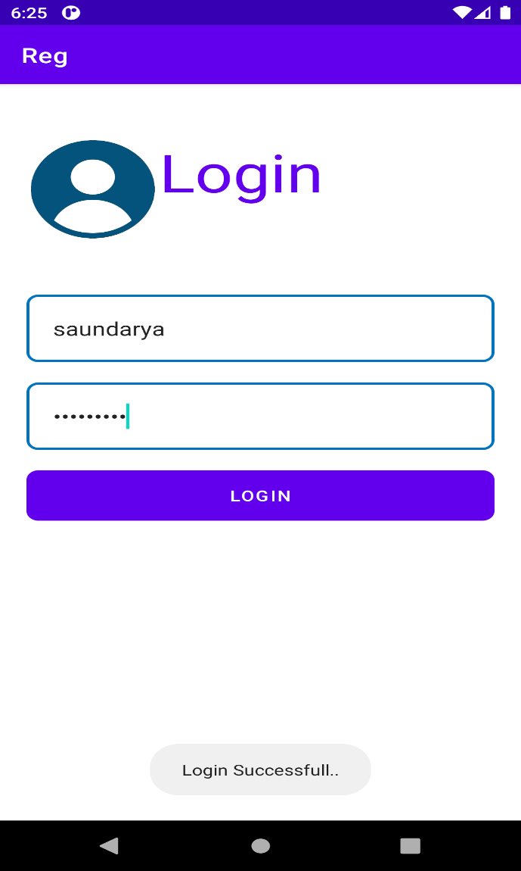 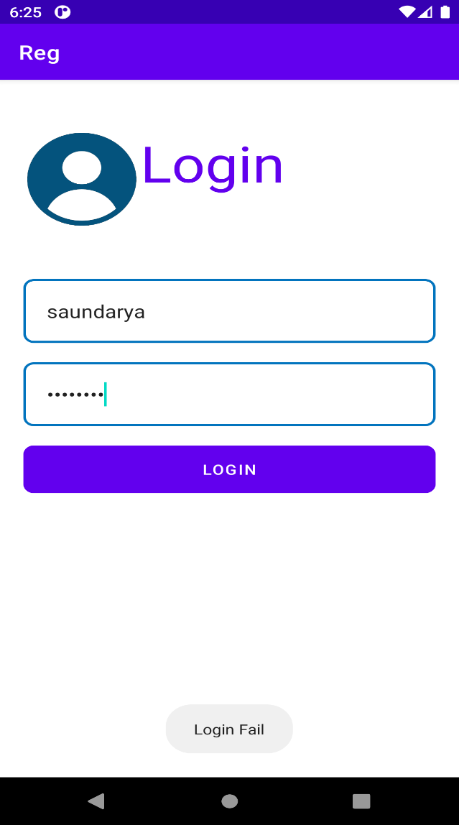

**7.Design a simple calculator app**

<?xml version="1.0" encoding="utf-8"?>

<RelativeLayout xmlns:android="http://schemas.android.com/apk/res/android"

xmlns:tools="http://schemas.android.com/tools"

android:id="@+id/relative1"

android:layout_width="match_parent"

android:layout_height="match_parent"

tools:context=".MainActivity">

<EditText

android:id="@+id/edt1"

android:layout_width="match_parent"

android:layout_height="wrap_content" />

<Button

android:id="@+id/button1"

style="?android:attr/buttonStyleSmall"

android:layout_width="wrap_content"

android:layout_height="wrap_content"

android:layout_alignEnd="@+id/button4"

android:layout_alignRight="@+id/button4"

android:layout_below="@+id/edt1"

android:layout_marginTop="94dp"

android:text="1" />

<Button

android:id="@+id/button2"

style="?android:attr/buttonStyleSmall"

android:layout_width="wrap_content"

android:layout_height="wrap_content"

android:layout_alignTop="@+id/button1"

android:layout_toLeftOf="@+id/button3"

android:layout_toStartOf="@+id/button3"

android:text="2" />

<Button

android:id="@+id/button3"

style="?android:attr/buttonStyleSmall"

android:layout_width="wrap_content"

android:layout_height="wrap_content"

android:layout_alignTop="@+id/button2"

android:layout_centerHorizontal="true"

android:text="3" />

<Button

android:id="@+id/button4"

style="?android:attr/buttonStyleSmall"

android:layout_width="wrap_content"

android:layout_height="wrap_content"

android:layout_below="@+id/button1"

android:layout_toLeftOf="@+id/button2"

android:text="4" />

<Button

android:id="@+id/button5"

style="?android:attr/buttonStyleSmall"

android:layout_width="wrap_content"

android:layout_height="wrap_content"

android:layout_alignBottom="@+id/button4"

android:layout_alignLeft="@+id/button2"

android:layout_alignStart="@+id/button2"

android:text="5" />

<Button

android:id="@+id/button6"

style="?android:attr/buttonStyleSmall"

android:layout_width="wrap_content"

android:layout_height="wrap_content"

android:layout_alignLeft="@+id/button3"

android:layout_alignStart="@+id/button3"

android:layout_below="@+id/button3"

android:text="6" />

<Button

android:id="@+id/button7"

style="?android:attr/buttonStyleSmall"

android:layout_width="wrap_content"

android:layout_height="wrap_content"

android:layout_below="@+id/button4"

android:layout_toLeftOf="@+id/button2"

android:text="7" />

<Button

android:id="@+id/button8"

style="?android:attr/buttonStyleSmall"

android:layout_width="wrap_content"

android:layout_height="wrap_content"

android:layout_alignLeft="@+id/button5"

android:layout_alignStart="@+id/button5"

android:layout_below="@+id/button5"

android:text="8" />

<Button

android:id="@+id/button9"

style="?android:attr/buttonStyleSmall"

android:layout_width="wrap_content"

android:layout_height="wrap_content"

android:layout_alignLeft="@+id/button6"

android:layout_alignStart="@+id/button6"

android:layout_below="@+id/button6"

android:text="9" />

<Button

android:id="@+id/buttonadd"

style="?android:attr/buttonStyleSmall"

android:layout_width="wrap_content"

android:layout_height="wrap_content"

android:layout_alignEnd="@+id/edt1"

android:layout_alignRight="@+id/edt1"

android:layout_alignTop="@+id/button3"

android:layout_marginLeft="46dp"

android:layout_marginStart="46dp"

android:layout_toRightOf="@+id/button3"

android:text="+" />

<Button

android:id="@+id/buttonsub"

style="?android:attr/buttonStyleSmall"

android:layout_width="wrap_content"

android:layout_height="wrap_content"

android:layout_alignEnd="@+id/buttonadd"

android:layout_alignLeft="@+id/buttonadd"

android:layout_alignRight="@+id/buttonadd"

android:layout_alignStart="@+id/buttonadd"

android:layout_below="@+id/buttonadd"

android:text="-" />

<Button

android:id="@+id/buttonmul"

style="?android:attr/buttonStyleSmall"

android:layout_width="wrap_content"

android:layout_height="wrap_content"

android:layout_alignLeft="@+id/buttonsub"

android:layout_alignParentEnd="true"

android:layout_alignParentRight="true"

android:layout_alignStart="@+id/buttonsub"

android:layout_below="@+id/buttonsub"

android:text="*" />

<Button

android:id="@+id/button10"

style="?android:attr/buttonStyleSmall"

android:layout_width="wrap_content"

android:layout_height="wrap_content"

android:layout_below="@+id/button7"

android:layout_toLeftOf="@+id/button2"

android:text="." />

<Button

android:id="@+id/button0"

style="?android:attr/buttonStyleSmall"

android:layout_width="wrap_content"

android:layout_height="wrap_content"

android:layout_alignLeft="@+id/button8"

android:layout_alignStart="@+id/button8"

android:layout_below="@+id/button8"

android:text="0" />

<Button

android:id="@+id/buttonC"

style="?android:attr/buttonStyleSmall"

android:layout_width="wrap_content"

android:layout_height="wrap_content"

android:layout_alignLeft="@+id/button9"

android:layout_alignStart="@+id/button9"

android:layout_below="@+id/button9"

android:text="C" />

<Button

android:id="@+id/buttondiv"

style="?android:attr/buttonStyleSmall"

android:layout_width="wrap_content"

android:layout_height="wrap_content"

android:layout_alignEnd="@+id/buttonmul"

android:layout_alignLeft="@+id/buttonmul"

android:layout_alignRight="@+id/buttonmul"

android:layout_alignStart="@+id/buttonmul"

android:layout_below="@+id/buttonmul"

android:text="/" />

<Button

android:id="@+id/buttoneql"

android:layout_width="wrap_content"

android:layout_height="wrap_content"

android:layout_alignEnd="@+id/buttondiv"

android:layout_alignLeft="@+id/button10"

android:layout_alignRight="@+id/buttondiv"

android:layout_alignStart="@+id/button10"

android:layout_below="@+id/button0"

android:layout_marginTop="37dp"

android:text="=" />

</RelativeLayout>

**Activity_main_java**

package com.crunchify.tutorials.crunchifycalculator;

import android.os.Bundle;

import android.support.v7.app.AppCompatActivity;

import android.view.View;

import android.widget.Button;

import android.widget.EditText;

public class MainActivity extends AppCompatActivity {

Button button0, button1, button2, button3, button4, button5, button6,

button7, button8, button9, buttonAdd, buttonSub, buttonDivision,

buttonMul, button10, buttonC, buttonEqual;

EditText crunchifyEditText;

float mValueOne, mValueTwo;

boolean crunchifyAddition, mSubtract, crunchifyMultiplication, crunchifyDivision;

@Override

protected void onCreate(Bundle savedInstanceState) {

super.onCreate(savedInstanceState);

setContentView(R.layout.activity_main);

button0 = (Button) findViewById(R.id.button0);

button1 = (Button) findViewById(R.id.button1);

button2 = (Button) findViewById(R.id.button2);

button3 = (Button) findViewById(R.id.button3);

button4 = (Button) findViewById(R.id.button4);

button5 = (Button) findViewById(R.id.button5);

button6 = (Button) findViewById(R.id.button6);

button7 = (Button) findViewById(R.id.button7);

button8 = (Button) findViewById(R.id.button8);

button9 = (Button) findViewById(R.id.button9);

button10 = (Button) findViewById(R.id.button10);

buttonAdd = (Button) findViewById(R.id.buttonadd);

buttonSub = (Button) findViewById(R.id.buttonsub);

buttonMul = (Button) findViewById(R.id.buttonmul);

buttonDivision = (Button) findViewById(R.id.buttondiv);

buttonC = (Button) findViewById(R.id.buttonC);

buttonEqual = (Button) findViewById(R.id.buttoneql);

crunchifyEditText = (EditText) findViewById(R.id.edt1);

button1.setOnClickListener(new View.OnClickListener() {

@Override

public void onClick(View v) {

crunchifyEditText.setText(crunchifyEditText.getText() + "1");

}

});

button2.setOnClickListener(new View.OnClickListener() {

@Override

public void onClick(View v) {

crunchifyEditText.setText(crunchifyEditText.getText() + "2");

}

});

button3.setOnClickListener(new View.OnClickListener() {

@Override

public void onClick(View v) {

crunchifyEditText.setText(crunchifyEditText.getText() + "3");

}

});

button4.setOnClickListener(new View.OnClickListener() {

@Override

public void onClick(View v) {

crunchifyEditText.setText(crunchifyEditText.getText() + "4");

}

});

button5.setOnClickListener(new View.OnClickListener() {

@Override

public void onClick(View v) {

crunchifyEditText.setText(crunchifyEditText.getText() + "5");

}

});

button6.setOnClickListener(new View.OnClickListener() {

@Override

public void onClick(View v) {

crunchifyEditText.setText(crunchifyEditText.getText() + "6");

}

});

button7.setOnClickListener(new View.OnClickListener() {

@Override

public void onClick(View v) {

crunchifyEditText.setText(crunchifyEditText.getText() + "7");

}

button8.setOnClickListener(new View.OnClickListener() {

@Override

public void onClick(View v) {

crunchifyEditText.setText(crunchifyEditText.getText() + "8");

}

});

button9.setOnClickListener(new View.OnClickListener() {

@Override

public void onClick(View v) {

crunchifyEditText.setText(crunchifyEditText.getText() + "9");

}

});

button0.setOnClickListener(new View.OnClickListener() {

@Override

public void onClick(View v) {

crunchifyEditText.setText(crunchifyEditText.getText() + "0");

}

})

buttonAdd.setOnClickListener(new View.OnClickListener() {

@Override

public void onClick(View v) {

if (crunchifyEditText == null) {

crunchifyEditText.setText("");

} else {

mValueOne = Float.parseFloat(crunchifyEditText.getText() + "");

crunchifyAddition = true;

crunchifyEditText.setText(null);

}

}

});

buttonSub.setOnClickListener(new View.OnClickListener() {

@Override

public void onClick(View v) {

mValueOne = Float.parseFloat(crunchifyEditText.getText() + "");

mSubtract = true;

crunchifyEditText.setText(null);

}

});

buttonMul.setOnClickListener(new View.OnClickListener() {

@Override

public void onClick(View v) {

mValueOne = Float.parseFloat(crunchifyEditText.getText() + "");

crunchifyMultiplication = true;

crunchifyEditText.setText(null);

}

});

buttonDivision.setOnClickListener(new View.OnClickListener() {

@Override

public void onClick(View v) {

mValueOne = Float.parseFloat(crunchifyEditText.getText() + "");

crunchifyDivision = true;

crunchifyEditText.setText(null);

}

});

buttonEqual.setOnClickListener(new View.OnClickListener() {

@Override

public void onClick(View v) {

mValueTwo = Float.parseFloat(crunchifyEditText.getText() + "");

if (crunchifyAddition == true) {

crunchifyEditText.setText(mValueOne + mValueTwo + "");

crunchifyAddition = false;

}

if (mSubtract == true) {

crunchifyEditText.setText(mValueOne - mValueTwo + "");

mSubtract = false;

}

if (crunchifyMultiplication == true) {

crunchifyEditText.setText(mValueOne * mValueTwo + "");

crunchifyMultiplication = false;

}

if (crunchifyDivision == true) {

crunchifyEditText.setText(mValueOne / mValueTwo + "");

crunchifyDivision = false;

}

}

});

buttonC.setOnClickListener(new View.OnClickListener() {

@Override

public void onClick(View v) {

crunchifyEditText.setText("");

}

});

button10.setOnClickListener(new View.OnClickListener() {

@Override

public void onClick(View v) {

crunchifyEditText.setText(crunchifyEditText.getText() + ".");

}

});

}

}

**OUTPUT**

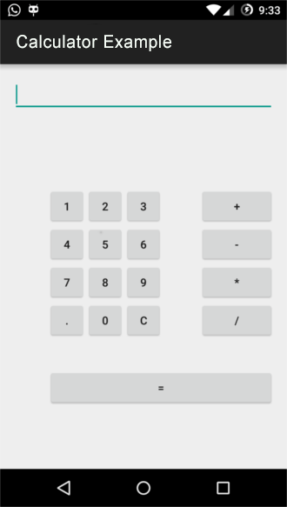

***8.Design a BMI calculator Application***

*<?xml version="1.0" encoding="utf-8"?>*

*<LinearLayout xmlns:android="http://schemas.android.com/apk/res/android"*

*xmlns:tools="http://schemas.android.com/tools"*

*android:id="@+id/activity_main"*

*android:layout_width="match_parent"*

*android:layout_height="match_parent"*

*android:paddingBottom="@dimen/activity_vertical_margin"*

*android:paddingLeft="@dimen/activity_horizontal_margin"*

*android:paddingRight="@dimen/activity_horizontal_margin"*

*android:paddingTop="@dimen/activity_vertical_margin"*

*android:orientation="vertical"*

*tools:context="com.ssaurel.bmicalculator.MainActivity">*

*<TextView*

*android:text="@string/weight"*

*android:layout_width="wrap_content"*

*android:layout_height="wrap_content"*

*android:layout_gravity="center_horizontal"*

*android:gravity="center_horizontal"*

*android:layout_marginTop="50dp"*

*android:textSize="20sp"/>*

*<EditText*

*android:id="@+id/weight"*

*android:layout_width="wrap_content"*

*android:layout_height="wrap_content"*

*android:layout_gravity="center_horizontal"*

*android:layout_marginTop="10dp"*

*android:ems="6"*

*android:inputType="number|numberDecimal"*

*android:textSize="20sp"/>*

*<TextView*

*android:text="@string/height"*

*android:layout_width="wrap_content"*

*android:layout_height="wrap_content"*

*android:layout_gravity="center_horizontal"*

*android:gravity="center_horizontal"*

*android:layout_marginTop="50dp"*

*android:textSize="20sp"/>*

*<EditText*

*android:id="@+id/height"*

*android:layout_width="wrap_content"*

*android:layout_height="wrap_content"*

*android:layout_gravity="center_horizontal"*

*android:layout_marginTop="10dp"*

*android:ems="6"*

*android:inputType="number|numberDecimal"*

*android:textSize="20sp"/>*

*<Button*

*android:id="@+id/calc"*

*android:layout_width="wrap_content"*

*android:layout_height="wrap_content"*

*android:layout_gravity="center_horizontal"*

*android:layout_marginTop="25dp"*

*android:onClick="calculateBMI"*

*android:text="@string/calculateBMI" />*

*<TextView*

*android:id="@+id/result"*

*android:layout_width="wrap_content"*

*android:layout_height="wrap_content"*

*android:layout_gravity="center_horizontal"*

*android:gravity="center_horizontal"*

*android:layout_marginTop="25dp"*

*android:textSize="20sp"/>*

*</LinearLayout>*

***Activity_main_java***

package com.ssaurel.bmicalculator;

import android.os.Bundle;

import android.support.v7.app.AppCompatActivity;

import android.view.View;

import android.widget.EditText;

import android.widget.TextView;

public class MainActivity extends AppCompatActivity {

private EditText height;

private EditText weight;

private TextView result;

@Override

protected void onCreate(Bundle savedInstanceState) {

super.onCreate(savedInstanceState);

setContentView(R.layout.activity_main);

height = (EditText) findViewById(R.id.height);

weight = (EditText) findViewById(R.id.weight);

result = (TextView) findViewById(R.id.result);

}

public void calculateBMI(View v) {

String heightStr = height.getText().toString();

String weightStr = weight.getText().toString()

if (heightStr != null && !"".equals(heightStr)

&& weightStr != null && !"".equals(weightStr)) {

float heightValue = Float.parseFloat(heightStr) / 100;

float weightValue = Float.parseFloat(weightStr);

float bmi = weightValue / (heightValue * heightValue);

displayBMI(bmi);

}

}

private void displayBMI(float bmi) {

String bmiLabel = "";

if (Float.compare(bmi, 15f) <= 0) {

bmiLabel = getString(R.string.very_severely_underweight);

} else if (Float.compare(bmi, 15f) > 0 && Float.compare(bmi, 16f) <= 0) {

bmiLabel = getString(R.string.severely_underweight);

} else if (Float.compare(bmi, 16f) > 0 && Float.compare(bmi, 18.5f) <= 0) {

bmiLabel = getString(R.string.underweight);

} else if (Float.compare(bmi, 18.5f) > 0 && Float.compare(bmi, 25f) <= 0) {

bmiLabel = getString(R.string.normal);

} else if (Float.compare(bmi, 25f) > 0 && Float.compare(bmi, 30f) <= 0) {

bmiLabel = getString(R.string.overweight);

} else if (Float.compare(bmi, 30f) > 0 && Float.compare(bmi, 35f) <= 0) {

bmiLabel = getString(R.string.obese_class_i);

} else if (Float.compare(bmi, 35f) > 0 && Float.compare(bmi, 40f) <= 0) {

bmiLabel = getString(R.string.obese_class_ii);

} else {

bmiLabel = getString(R.string.obese_class_iii);

}

bmiLabel = bmi + "\n\n" + bmiLabel;

result.setText(bmiLabel);

}

}

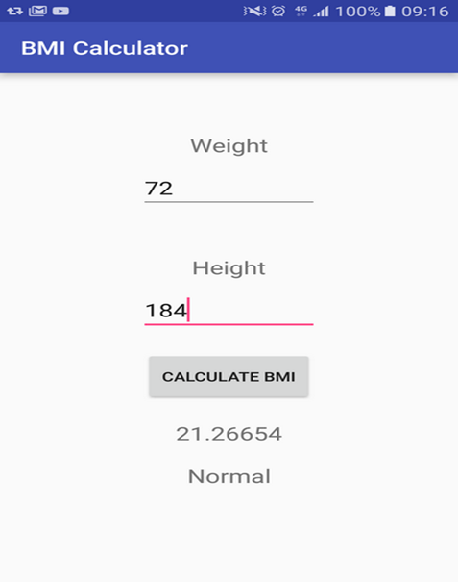

**9.Design an android app to create a page using intent and one button and pass the value from one activity to second activity**

<?xml version = "1.0" encoding = "utf-8"?>

<LinearLayout xmlns:android = "http://schemas.android.com/apk/res/android"

xmlns:tools = "http://schemas.android.com/tools"

android:layout_width = "match_parent"

android:layout_height = "match_parent"

android:layout_margin = "16dp"

android:orientation = "vertical"

tools:context = ".MainActivity">

<EditText

android:id = "@+id/etName"

android:layout_width = "match_parent"

android:layout_height = "wrap_content"

android:layout_gravity = "center"

android:hint = "Name"

android:inputType = "text" />

<EditText

android:id = "@+id/etAge"

android:layout_width = "match_parent"

android:layout_height = "wrap_content"

android:layout_gravity = "center"

android:hint = "Age"

android:inputType = "number" />

<Button

android:id = "@+id/button"

android:layout_width = "match_parent"

android:layout_height = "wrap_content"

android:layout_gravity = "center"

android:layout_marginTop = "16dp"

android:text = "Next" />

</LinearLayout>

package com.example.myapplication;

import android.content.Intent;

import android.os.Bundle;

import android.support.v7.app.AppCompatActivity;

import android.view.View;

import android.widget.Button;

import android.widget.EditText;

public class MainActivity extends AppCompatActivity {

EditText etName, etAge;

@Override

protected void onCreate(Bundle savedInstanceState) {

super.onCreate(savedInstanceState);

setContentView(R.layout.activity_main);

etName = findViewById(R.id.etName);

etAge = findViewById(R.id.etAge);

Button button = findViewById(R.id.button);

button.setOnClickListener(new View.OnClickListener() {

@Override

public void onClick(View v) {

String name = etName.getText().toString().trim();

String age = etAge.getText().toString().trim();

Bundle bundle = new Bundle();

bundle.putString("name", name);

bundle.putString("age", age);

Intent intent = new Intent(MainActivity.this, SecondActivity.class);

intent.putExtras(bundle);

startActivity(intent);

}

});

}

}

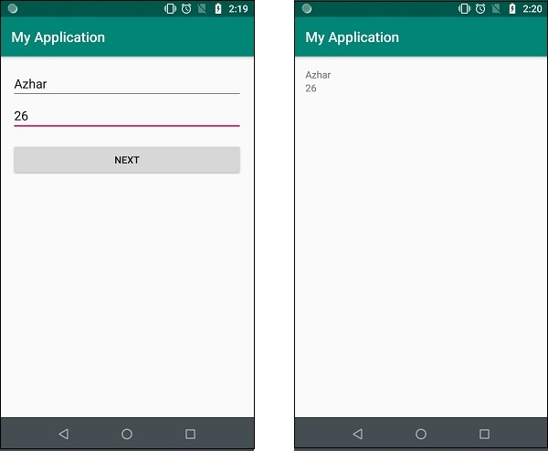

**10) Develop an application which has textarea , textview, 2 buttons named one as LowercaseTransform and other as UppercaseTransform, widgets. Take input from textarea and if user clicks on LowercaseTransform button then convert all text to lowercase or if clicks on UppercaseTransform button then convert all text into uppercase, and display it on textview.**